Jesus Nolazco

Chapter 10

**Page 258 Click event multiple actions**

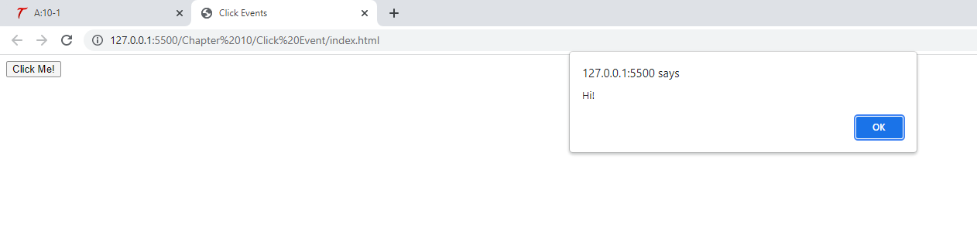

<!DOCTYPE html>

<html>

<head>

    <title>Click Events</title>

</head>

<body>

    <form>

        <input type="button" value="Click Me!" onclick="window.alert('Hi!'); window.alert('Bye!');">

    </form>

</body>

</html>

**Page 258 Use a function**

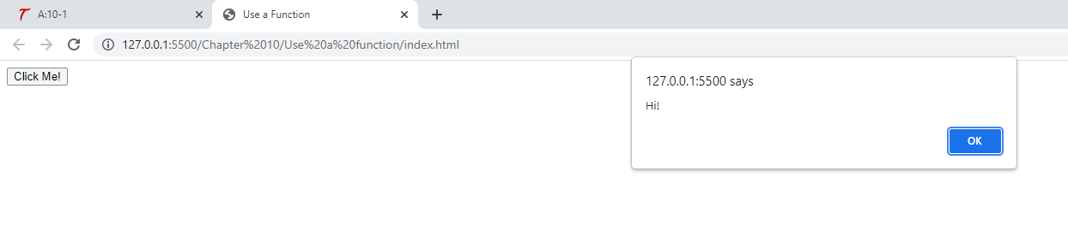

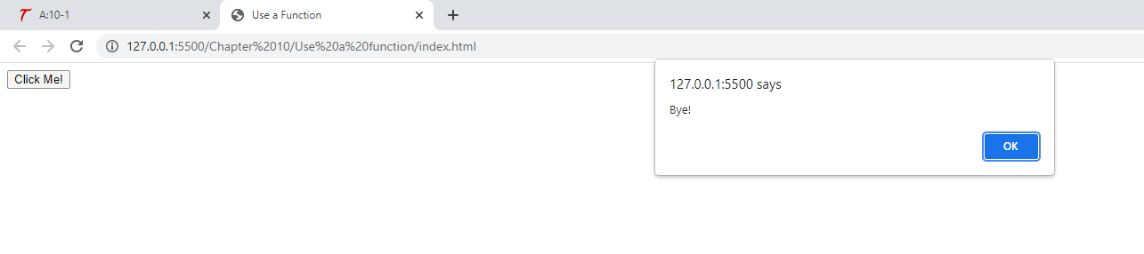

<!DOCTYPE html>

<html>

<head>

    <title>Use a Function</title>

</head>

<body>

    <form>

        <input type="button" value="Click Me!" onclick="hi_and_bye();">

    </form>

    <script src="js_event_01.js"></script>

</body>

</html>

function hi_and_bye() {

    window.alert('Hi!');

    window.alert('Bye!');

}

**259 Event Handler in script**

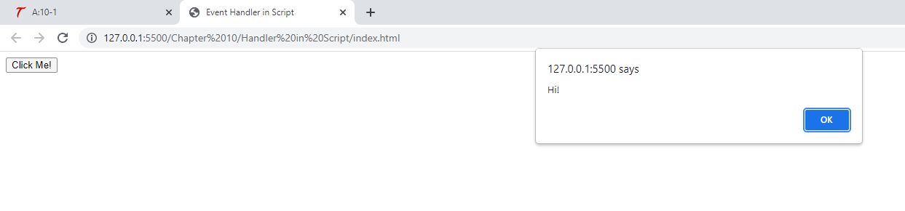

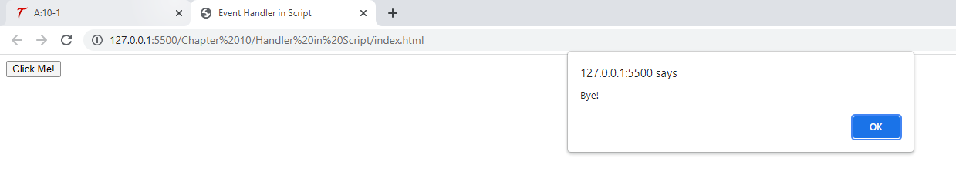

<!DOCTYPE html>

<html>

<head>

    <title>Event Handler in Script</title>

</head>

<body>

    <form>

        <input type="button" value="Click Me!" id="say_hi">

    </form>

    <script src="js_event_01.js"></script>

</body>

</html>

let hi_button = document.getElementById("say_hi");

hi_button.onclick = function() {

    window.alert('Hi!');

    window.alert('Bye!');

};

**Page 262 Click Event**

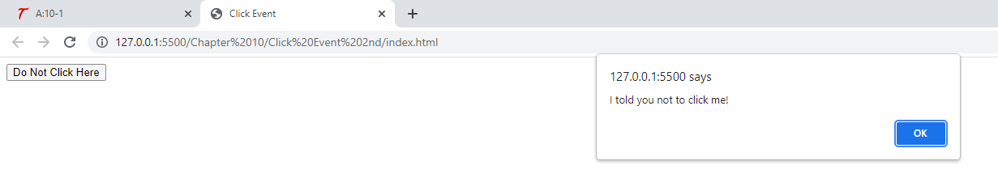

<!DOCTYPE html>

<html>

<head>

    <title>Click Event</title>

</head>

<body>

    <form>

        <input type="button" value="Do Not Click Here" onclick="window.alert('I told you not to click me!');">

    </form>

</body>

</html>

**263 Event handler problem**

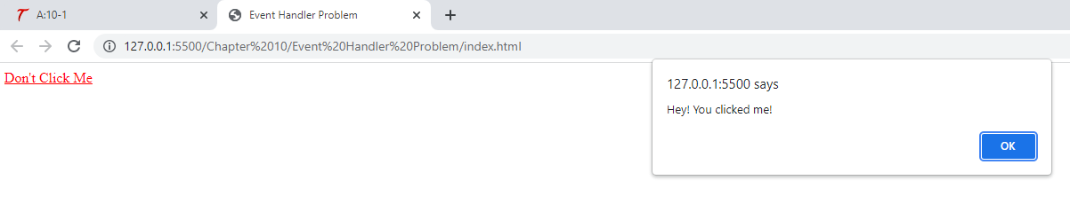

<!DOCTYPE html>

<html>

<head>

    <title>Event Handler Problem</title>

</head>

<body>

    <a href="http://none" onclick="window.alert('Hey! You clicked me!'); return false;">Don't Click Me</a>

</body>

</html>

**265 Blur Event**

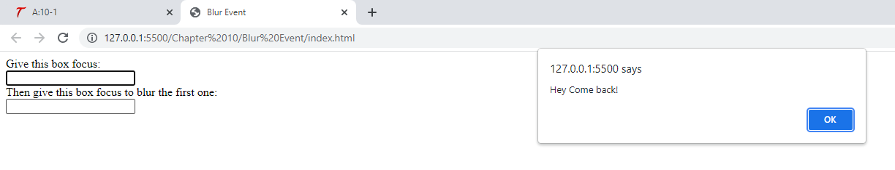

<!DOCTYPE html>

<html>

<head>

    <title>Blur Event</title>

</head>

<body>

    <form>

        Give this box focus:<br>

        <input type="text" onblur="window.alert('Hey Come back!');"><br> Then give this box focus to blur the first one:<br>

        <input type="text">

    </form>

</body>

</html>

**Page 268 Submit Form**

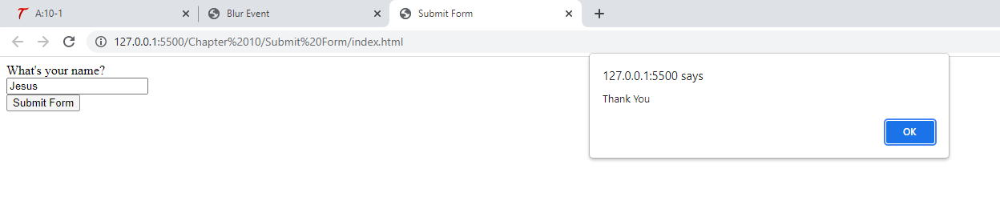

<!DOCTYPE html>

<html>

<head>

    <title>Submit Form</title>

</head>

<body>

    <form onsubmit="window.alert('Thank You');">

        What's your name?<br>

        <input type="text" id="thename"><br>

        <input type="submit" value="Submit Form">

    </form>

</body>

</html>

**269 onmouseover event**

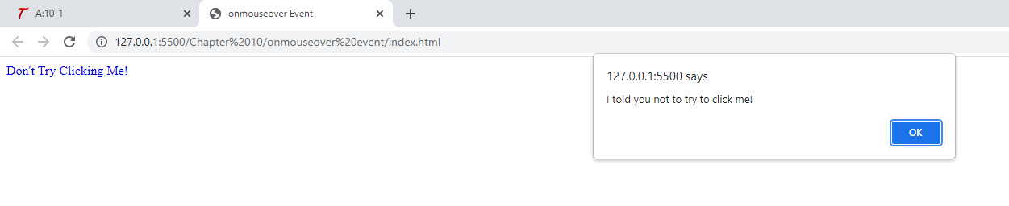

<!DOCTYPE html>

<html>

<head>

    <title>onmouseover Event</title>

</head>

<body>

    <a href="http://www.pageresource.com" onmouseover="window.alert('I told you not to try to click me!');">Don't Try Clicking Me!</a>

</body>

</html>

**Page 270 Try This 10-1**

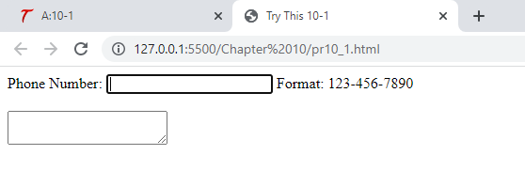

<!DOCTYPE html>

<html>

<head>

    <title>Try This 10-1</title>

</head>

<body>

    <form>

        Phone Number:

        <input type="text" id="pn"> <span id="reminder"></span><br><br>

        <textarea></textarea>

    </form>

    <script src="pr10_1.js"></script>

</body>

</html>

let pn = document.getElementById("pn"),

    rm = document.getElementById("reminder");

pn.onfocus = function() {

    rm.innerHTML = "Format: 123-456-7890";

};

pn.onblur = function() {

    rm.innerHTML = "";

}

**Page 273 addEventlistener()**

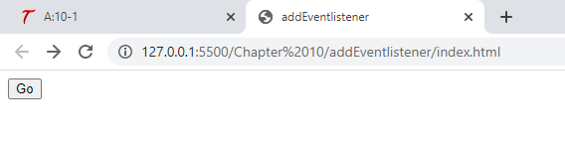

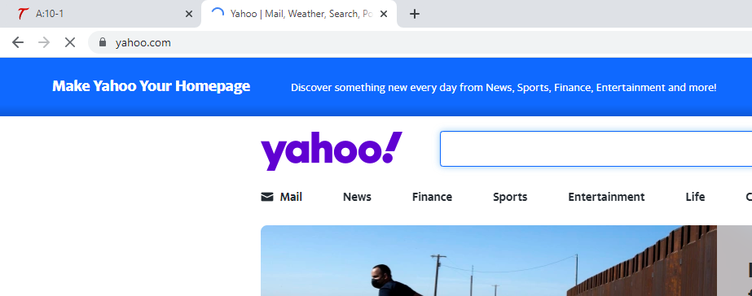

<!DOCTYPE html>

<html>

<head>

    <title>addEventlistener</title>

</head>

<body>

    <input type="button" id="btn1" value="Go">

    <script src="eventlistener.js"></script>

</body>

</html>

let web_page1 = "http://www.yahoo.com";

let b1 = document.getElementById("btn1");

b1.addEventListener("click", function() {

    window.location = web_page1;

}, false);

**Page 274 Event object**

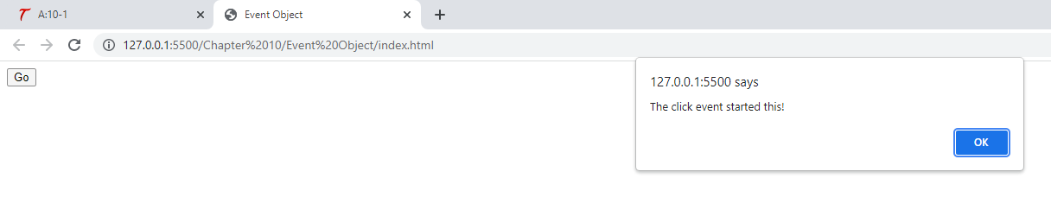

<!DOCTYPE html>

<html>

<head>

    <title>Event Object</title>

</head>

<body>

    <input type="button" id="btn1" value="Go">

    <script src="eventobject.js"></script>

</body>

</html>

let b1 = document.getElementById("btn1");

b1.onclick = function(event) {

    alert("The " + event.type + " event started this!");

};

**Page 275 window.event.type**

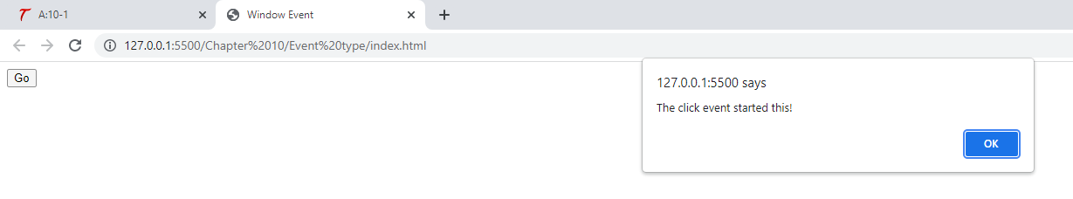

<!DOCTYPE html>

<html>

<head>

    <title>Window Event</title>

</head>

<body>

    <input type="button" id="btn1" value="Go">

    <script src="windowevent.js"></script>

</body>

</html>

let b1 = document.getElementById("btn1");

b1.onclick = function() {

    alert("The " + window.event.type + " event started this!");

};

**Page 275 event || window.event**

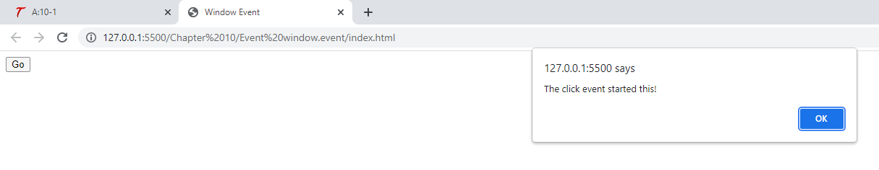

<!DOCTYPE html>

<html>

<head>

    <title>Window Event</title>

</head>

<body>

    <input type="button" id="btn1" value="Go">

    <script src="windowevent.js"></script>

</body>

</html>

let b1 = document.getElementById("btn1");

b1.onclick = function(event) {

    let e = event || window.event;

    alert("The " + e.type + " event started this!");

};

**Page 275 addEventlistener with event**

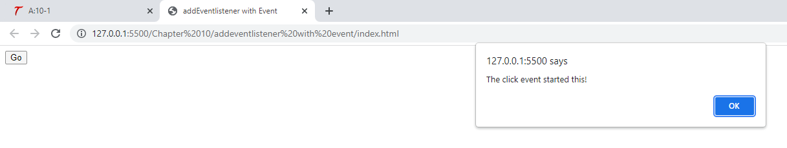

<!DOCTYPE html>

<html>

<head>

    <title>addEventlistener with Event</title>

</head>

<body>

    <input type="button" id="btn1" value="Go">

    <script src="event.js"></script>

</body>

</html>

let b1 = document.getElementById("btn1");

b1.addEventListener("click", function(event) {

    alert("The " + event.type + " event started this!");

}, false);

**278 Try This 10-2**

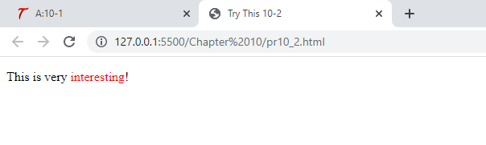

<!DOCTYPE html>

<html>

<head>

    <title>Try This 10-2</title>

</head>

<body>

    <p>This is very <span id="int">interesting</span>!</p>

    <script src="pr10_2.js"></script>

</body>

</html>

let int = document.getElementById("int");

int.addEventListener("mouseover", function() {

    int.style.color = "#FF0000";

}, false);

int.addEventListener("mouseout", function() {

    int.style.color = "#000000";

}, false);

**279-280 Show Hidden Content**

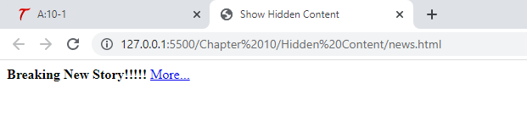

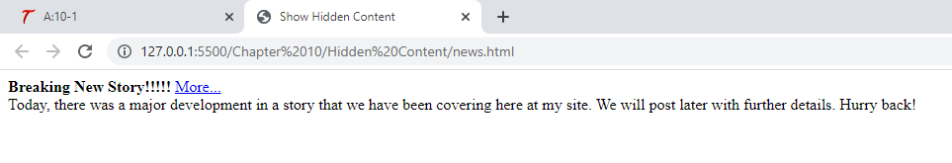

<!DOCTYPE html>

<html>

<head>

    <title>Show Hidden Content</title>

</head>

<body>

    <div>

        <strong>Breaking New Story!!!!!</strong>

        <a href="story.html" id="morelink">More...</a>

    </div>

    <div id="morediv">

        Today, there was a major development in a story that we have been covering here at my site. We will post later with further details. Hurry back!

    </div>

    <script src="news.js"></script>

</body>

</html>

let mlink = document.getElementById("morelink"),

    mdiv = document.getElementById("morediv");

mlink.addEventListener("click", function(event) {

    event.preventDefault();

    mdiv.style.display = (mdiv.style.display === "none") ? "block" :

        "none";

}, false);

mdiv.style.display = "none";

**281-284 Change content**

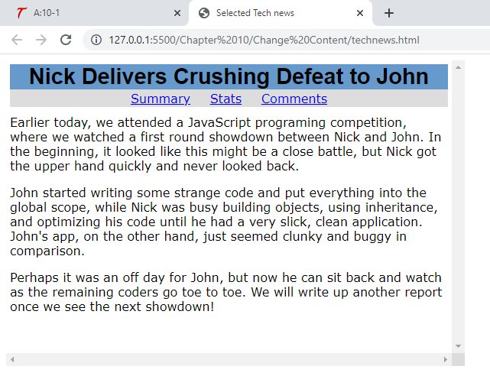

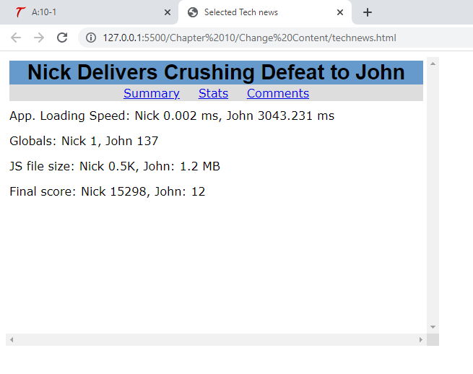

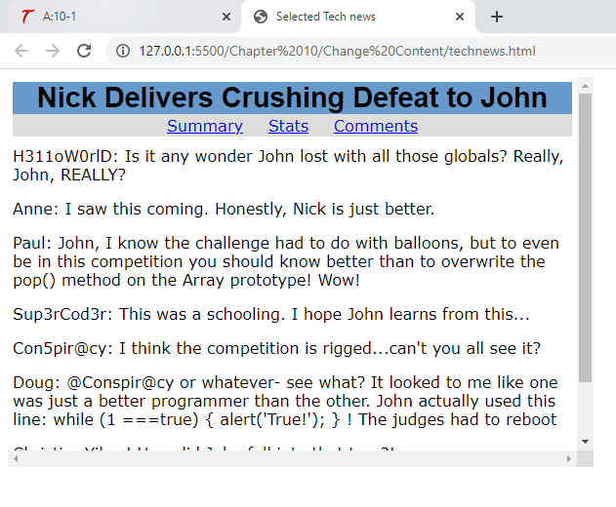

<html>

<head>

    <title>Selected Tech news</title>

    <link rel="stylesheet" type="text/css" href="technews.css">

</head>

<div class="wrapper">

    <div class="headline">Nick Delivers Crushing Defeat to John</div>

    <div id="top_story_nav" class="story_nav">

        <a href="#sumdiv" id="sumlink">Summary</a>

        <a href="#statsdiv" id="statslink">Stats</a>

        <a href="#comdiv" id="comlink">Comments</a>

    </div>

    <div id="sumdiv" class="spart">

        Earlier today, we attended a JavaScript programing competition, where we watched a first round showdown between Nick and John. In the beginning, it looked like this might be a close battle, but Nick got the upper hand quickly and never looked back.

        <p>John started writing some strange code and put everything into the global scope, while Nick was busy building objects, using inheritance, and optimizing his code until he had a very slick, clean application. John's app, on the other hand, just

            seemed clunky and buggy in comparison.</p>

        <p>Perhaps it was an off day for John, but now he can sit back and watch as the remaining coders go toe to toe. We will write up another report once we see the next showdown!

        </p>

    </div>

    <div id="statsdiv" class="spart">

        App. Loading Speed: Nick 0.002 ms, John 3043.231 ms

        <p>Globals: Nick 1, John 137</p>

        <p>JS file size: Nick 0.5K, John: 1.2 MB</p>

        <p>Final score: Nick 15298, John: 12</p>

    </div>

    <div id="comdiv" class="spart">

        H311oW0rlD: Is it any wonder John lost with all those globals? Really, John, REALLY?

        <p>Anne: I saw this coming. Honestly, Nick is just better.</p>

        <p>Paul: John, I know the challenge had to do with balloons, but to even be in this competition you should know better than to overwrite the pop() method on the Array prototype! Wow!</p>

        <p>Sup3rCod3r: This was a schooling. I hope John learns from this...</p>

        <p>Con5pir@cy: I think the competition is rigged...can't you all see it?</p>

        <p>Doug: @Conspir@cy or whatever- see what? It looked to me like one was just a better programmer than the other. John actually used this line: while (1 ===true) { alert('True!'); } ! The judges had to reboot</p>

        <p>Christie: Yikes! How did John fall into that trap?!</p>

        <p>Z25S1l0O: Has the video been posted yet? I've gotta see this! lol!</p>

    </div>

</div>

<script type="text/javascript" src="technews.js"></script>

</body>

</html>

.wrapper {

    width: 590px;

    height: 390px;

    padding: 5px;

    overflow: scroll;

    font-size: 1em;

    font-family: Verdana, sans-serif;

}

.headline {

    font-weight: bold;

    font-size: 1.8em;

    font-family: Arial, sans-serif;

    background-color: #6699CC;

    text-align: center;

}

.story_nav {

    margin: 0 0 10px 0;

    padding: 2px;

    background-color: #DDD;

    word-spacing: 20px;

    text-align: center;

}

.spart {

    margin-bottom: 10px;

}

let slinks = [document.getElementById("sumlink"),

        document.getElementById("statslink"),

        document.getElementById("comlink")

    ],

    sdivs = [document.getElementById("sumdiv"),

        document.getElementById("statsdiv"),

        document.getElementById("comdiv")

    ];

function change_div(count) {

    slinks[count].addEventListener("click", function(event) {

        event.preventDefault();

        sdivs[count].style.display = "block";

        for (let j = 0; j < sdivs.length; j++) {

            if (j === count) {

                continue;

            } else {

                sdivs[j].style.display = "none";

            }

        }

    }, false);

}

for (let i = 0; i < slinks.length; i++) {

    change_div(i);

}

sdivs[1].style.display = "none";

sdivs[2].style.display = "none";

**Capture/Bubble**

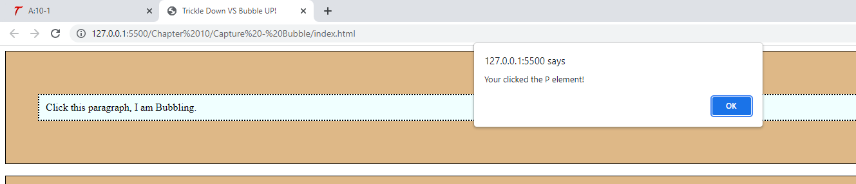

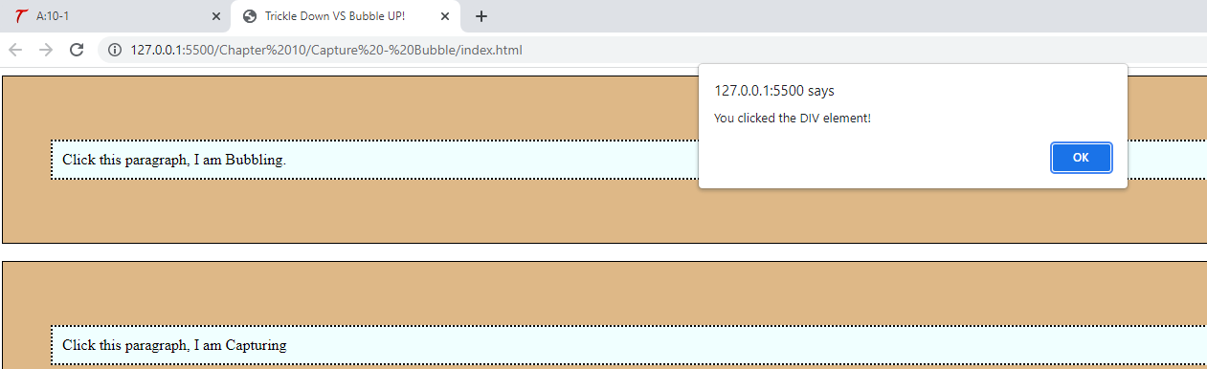

**The P element comes first when you click the bubbling paragraph.**

**The DIV element comes first when you click the capturing paragraph.**